 Writer’s Notebook

**Getting started:**

* Your first assignment is to decorate the outside of your writer’s notebook. Decorations should reflect your life and personality (show me that you love sports, music, art, your family…etc). These will also be helpful starting points for future entries.
* Use magazine clippings, pictures, drawings, and handwriting to jazz it up! Be creative.

**What goes inside:**

* Each week you will be required to write **three entries** in your notebook.
  + **Each entry must be at least one page.** *Poems may be a half a page if it is your best work.*
  + **One of the three entries must be relevant to a lesson from class**, whether that means implementing new vocabulary, a new strategy, or a new writing process.
  + Each entry must have a title centered on the top margin and the date on the upper right-hand corner. (*See below for an example)*
* Most importantly, put pride into your notebook. Be proud of your writing and work to make each entry better than the last ☺

Writer’s notebooks will be collected and graded every Friday. They will count as a quiz grade. I will be using a rubric to grade the three completed entries. \*\**See attached\*\**

**Sample Entry Format:**

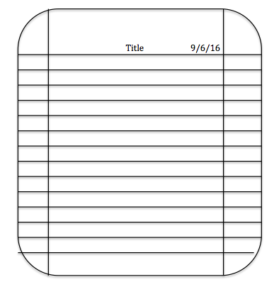

Date

Writer’s block?

Here are some ideas to get started:

* Family stories
* Personal narratives
* Poems
* Thoughts about what you’re currently reading
* A new ending for a favorite book or movie
* Your own song lyrics
* Places you would like to travel and activities you would plan
* Descriptive language to “paint a picture” of a familiar place
* Goals and how you plan to achieve them
* Write down an interview you did with a relative